AerE 462 Final Design Paper

Iowa State University

Spring 2018

Boeing White Team

Benjamin Halley

Michael Londergan

Anthony McDill

Alexis Moreno

Todd Nelson

Bailey Young



**Introduction**

Since the humble beginnings of the first flight of the Wright Brothers [1], aviation has always had the need and capability for growth in its versatility. From the introduction of the dangerous air mail routes in 1911 [2], to the introduction of the exquisite fighter airplane during WW1 for Air Warfare in 1914 [3], and to the world-changing commercialization of human transportation in 1914 [4] — aviation has always developed and overcome challenges that humans face. The expansion of aviation gave way to other forms of navigation and missions, such as the use of rotary-winged aircraft for adverse environments. With these aerospace developments, other industries have simultaneously undergone many changes. In particular, the transportation logistics that once limited the trade of goods and commodities around the world have given way to expansive trade routes through which all types of products are shipped more economically than ever before.

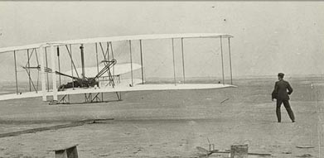

Figure 1: Wright Brothers’ First Flight, 1903 [1]

E-commerce and economy specialization has opened the doors to international trading becoming feasible. This feasibility for international trade requires a high degree of supply chain management and at the forefront of this activity is the international transportation of standardized containers. Although in some cases airmail is still used for extremely sensitive shipments and urgent expedited orders, the cost of expedited airmail does not allow for all goods to be delivered internationally. Instead, many commodity and time-insensitive, high-value goods are sent through large cargo holding ships, which carry containers certified by the International Organization for Standardization (ISO containers).

The movement of these ISO containers is still subjected to many potential issues, including piracy, loss at sea, and prohibitively expensive empty relocation costs. The biggest problem in the market from, a customer perspective -- and where aviation will adapt to create a solution -- is in the area of container dwell times. Shipping containers are viewed as a necessary equipment investment to generate revenue, and as such, represent a large expense when they are stuck at ports due to overloaded terminals and inland shipment delays.

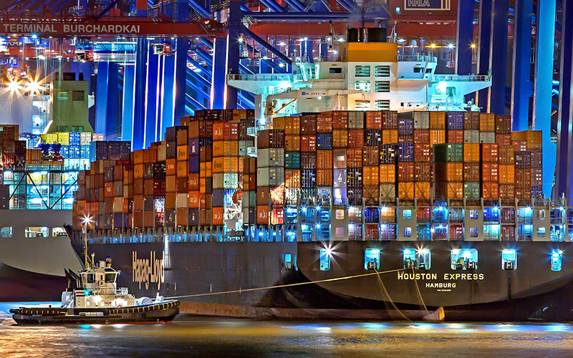

Figure 2: ISO containers awaiting to be unloaded off of a ship [5]

**Purpose**

The purpose of this white paper is to describe the process and finalized high-level design of a 2040 VTOL vehicle. This vehicle’s primary design is to have the capability to move high value shipping containers from moving ship, near ports, to nearby warehouses, by passing the busy and slow harbor facilities. The aircraft will have to be capable of vertical take-off and landing in the proposed environment. The following requirements and guidelines have been developed in order to maintain the vehicle design within customer wants [6]:

* The vehicle shall be capable of Vertical Take-Off and Landing (VTOL) maneuvers, to include probable technologies available for production in 2040
* The aircraft is to be designed for hover-based ISO container pickup from ocean container ships and land-based delivery
* The operating scenario is considered:
  + Primary base for aircraft daily maintenance and fueling is 25NM from the primary loading/unloading port
  + Primary warehouse is 60NM from the primary loading/unloading port
  + Aircraft base and warehouse facilities are considered to be at Sea Level Pressure Altitude, and ISA HOT Day atmospheric conditions
  + A mission day is limited to 14 flight hours, which can include day or nighttime operations
* The vehicle shall provide transport for one or more 20 foot or 40 foot ISO containers
* Representative times for hover pick up/deliver of the container and refueling are to be defined by the design teams
* The vehicle(s) shall have the capability to land safely if a “one engine inoperative” event occurs during transit
* The vehicle shall have 20 minutes of cruise reserve energy (fuel) at all times during the mission
* 80% of aircraft materials by mass shall be recyclable. Environmentally hazardous materials shall make up no more than 5% of the aircraft mass

**Executive Summary**

The Boeing ISOLifter is a fully functional autonomous aircraft capable of transporting ISO containers from ships that are near ports to customer warehouses up to 60NM away. The ISOLifter is fully integrated with a container handling system. This container handling system is designed to lift both 20’ (1TEU) and 40’ (2 TEU) containers. A variety of 2040 technology is utilized to ensure the vehicle platform remains economically efficient and safe to operate throughout its 30 year expected life.

**Market Analysis**

Currently, delays associated with container logistics cause significant additional expense to high-value goods imported to the United States. In California ports, containers sit dockside for an average of 2.5 days before they are dispatched from the holding area to their final destination, typically via inland truck transportation. During especially busy port times, containers can sit for greater than 5 business days, as shown in data collected by the Pacific Merchant Shipping Association in 2016 [7].

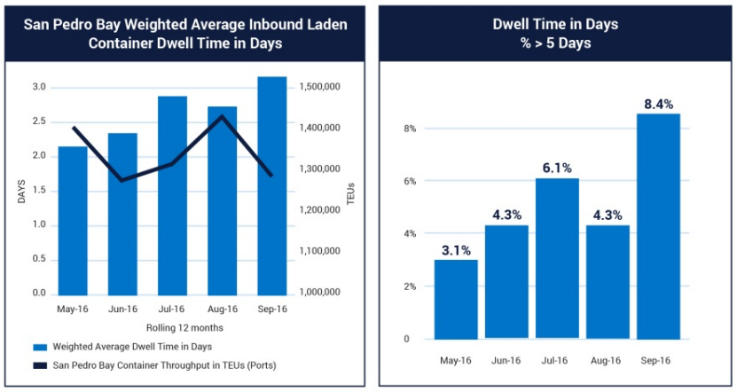

Figure 3: Average and Maximum Container Dwell Times at San Pedro Bay [7]

The selection of cargo capacity was driven by performance iterations done using an aircraft sizing code developed by the team, while the cargo value was driven by a survey of potential target markets currently using ISO shipping containers to transport high-value goods. The design team wanted to ensure a large enough customer base for continued aircraft operations from 2040-2070, assuming an average aircraft lifetime of 30 years. This market space is shown in Figure 4. A final cargo capacity of 16,000 lbs was determined, leading to a total expendable weight of 24,000 lbs for a 2 TEU shipping container with high-value goods. This is well below the maximum loading capacity of a 40’ shipping container. However, many high-value goods are shipped as full container loads even though the cargo does not reach the volume and/or weight limits of the container [8]. Oftentimes this choice is driven by shipping speed requirements, but in the case of refrigerated cargo, such as pharmaceutical goods, it can also be the result of airflow requirements inside of containers.

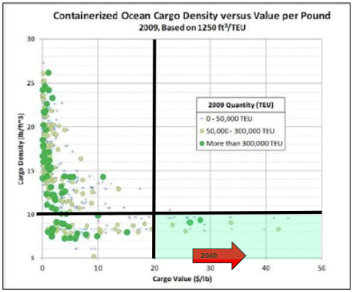

Figure 4: Maximum cargo density and minimum value threshold [6]

By analyzing annual cargo tonnage and declared values per import product category collected by US Customs and Port Authorities, the average value per pound of 99 cargo types imported into major US ports was found for the last 7 years. This data is compiled in the publically-available US Port Dataset [9]. The highest value commodities, on a per-pound basis, are shown in Table 1 below. Each cargo category was then compared against density classes provided by the National Motor Freight Traffic (NMFT) Association, and the cargoes most likely to meet the 10 lb/ft3 or less density requirement are highlighted in green as final target markets for the Boeing ISOLifter concept of operations [10, 11].

Table 1: High-value ISO container goods

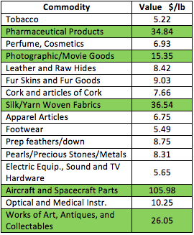

Using the NMFT shipping density ranges and typical volumetric container capacities for high-value goods being shipped as full container loads, the estimated gross weight of a container shipment for each category was calculated for a range of representative product densities in Table 2. Reductions in overall container capacity are assumed to be due to less than container load (LCL) shipping and packaging/support material that can take up significant volume but is required for stable shipment of goods. The results of this study were supported by the sizing code, which confirmed an upper loaded container weight of 24,000 lbs was attainable and economical by 2040 with aircraft performance improvements which are detailed further in this report.

Table 2: Container expendable weight trade study results

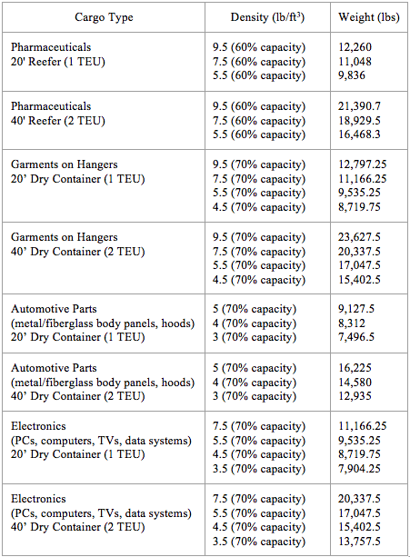



**Vehicle Design**

Initially, the team decided that the best type of VTOL vehicle for this project was the tandem helicopter. This decision was made through multiple trade studies and QFDs, and the tandem helicopter demonstrates both the best performance and the best adherence to the characteristics the team values within this mission. The base system was modeled loosely on a Chinook, this configuration was then analysed and edited through a sizing code, closing code, and CFD analysis.

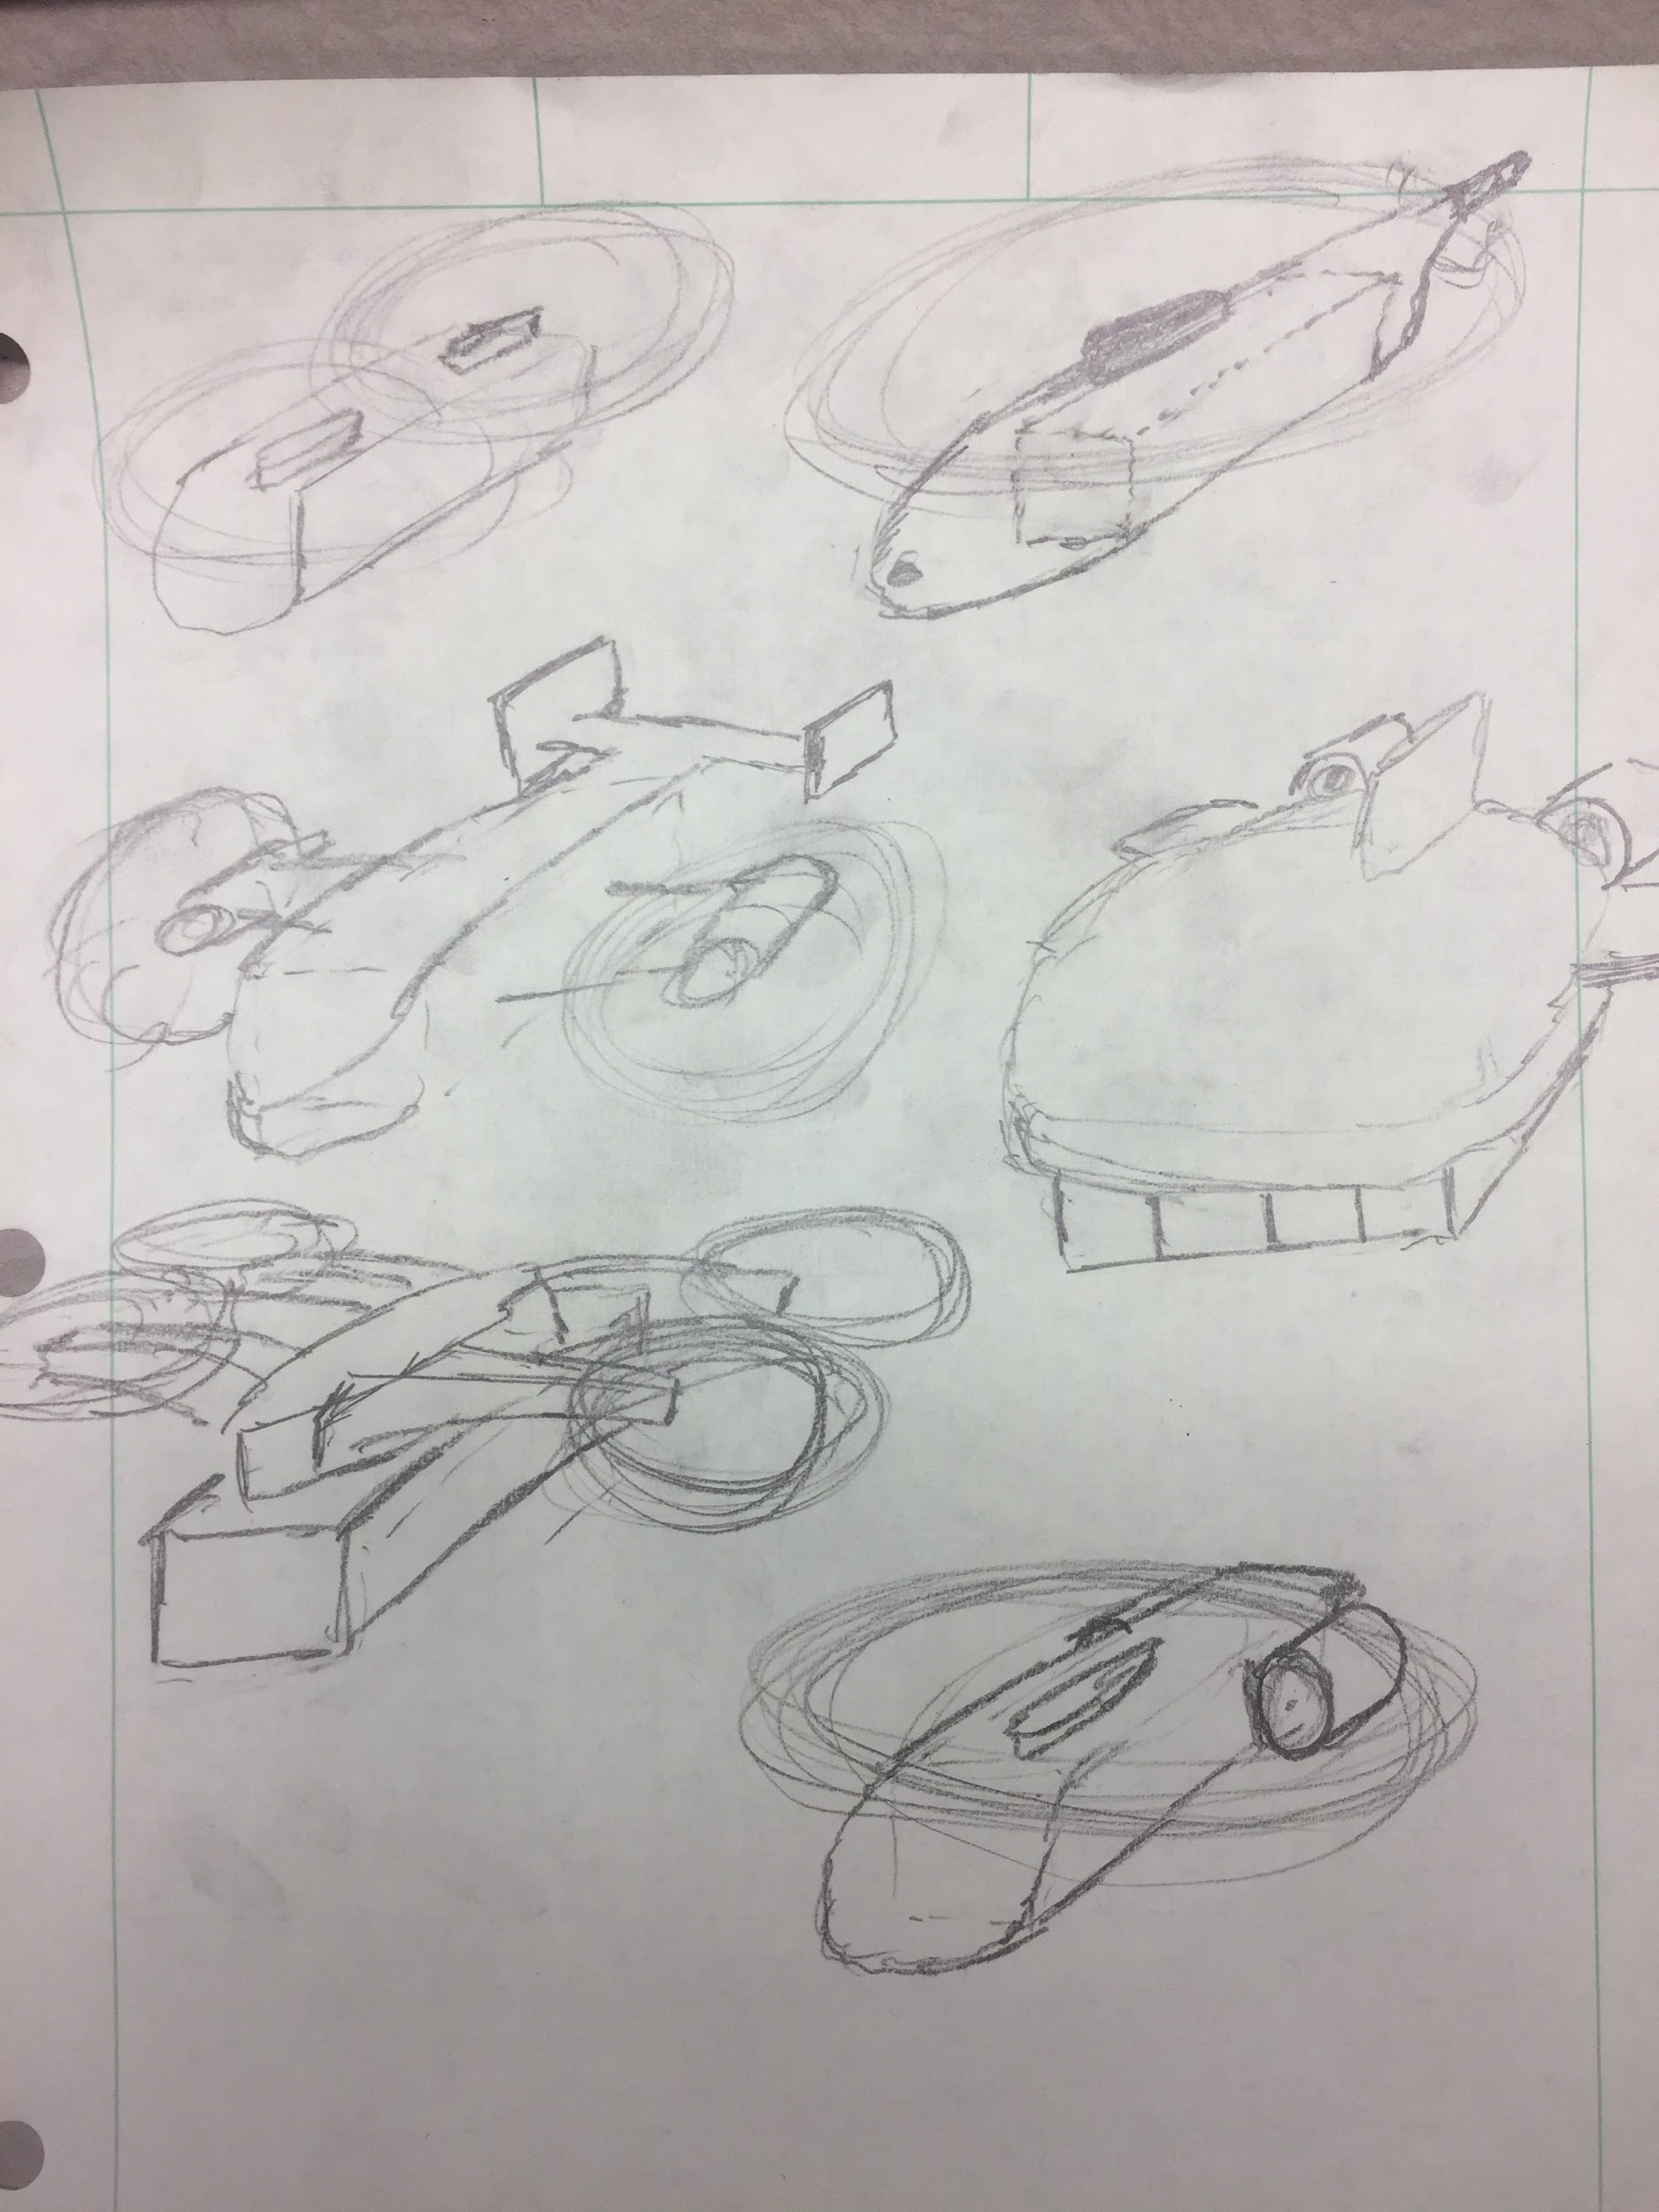

Figure 5: Initial Vehicle Idealization

The team developed two aircraft size, weight, and power (SWaP) codes throughout the year-long project. The first of these was an aircraft sizing code. This code used a historical helicopter weight correlation to converge on an aircraft size based on mission requirements and the weight correlation. This started with an assumed aircraft weight and did a SWaP analysis through the mission steps. It then used the error between the mission analysis and the historical correlation to get an updated weight for the next iteration. This was repeated until there was a convergence (error below acceptable limit).

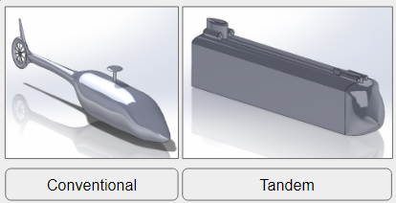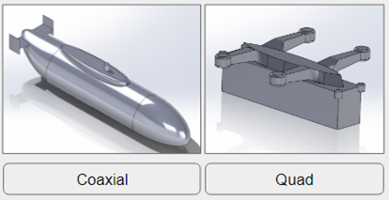

Figure 6: Initial Vehicle Designs for initial SWaP Sizing code

Inputs that define each aircraft configuration include rotor diameter, number of rotors, drag data, brake specific fuel consumption (BSFC), mechanical and aerodynamic efficiencies. Mission inputs include payload weight, fixed weight, range of segments, times for hover operations, time for loiter, climb data, and number of trips looped from the ship to the warehouse before aircraft refueling is required. Outputs include power requirements, weight, cruise and loiter velocities, fuel, and vehicle operating cost based on Boeing’s historical rotorcraft cost equation.

Each configuration was analysed through a mission model to determine the energy and power requirements for the given size and weight. All flight calculations were carried out using blade momentum theory. Below is a table of the mission segments with notes about assumptions and calculations.

Table 3: Analysis Mission Model

|  |  |  |
| --- | --- | --- |
| **Mission phase** | **Mission segment** | **Notes** |
| **Base to ship** | Warm up | Assumes 1% of gross weight fuel burn |
| Takeoff | Hover for 3 minutes |
| Climb with acceleration | Assume 83% of hover power through time to climb and accelerate |
| Cruise: base to ship (25 NM) | Steady level flight at max range velocity |
| **Ship to warehouse**  **(Looped for number of trips)** | Pickup | Hover 3 minutes without container load |
| Takeoff | Hover 3 minutes with container load |
| Climb with acceleration | 83% of hover power with container |
| Cruise: ship to warehouse (60 NM) | Max range velocity with container |
| Drop Off | Hover 3 minutes with container load |
| Takeoff | Hover 3 minutes without container load |
| Climb with acceleration | 83% of hover power without container |
| Cruise: warehouse to ship (60 NM) | Max range velocity without container load |
| **Warehouse to base** | Cruise: ship to base (25 NM) | Max range velocity without container load |
| Loiter (20 min) | Max endurance velocity without container, demonstrates 20 min fuel reserve |
| Land | Hover for 3 minutes |

The historical weight correlation related empty weight and gross takeoff weight. However the initial takeoff of this aircraft is not the maximum gross weight. As a result the maximum weight from each mission analysis was used to correlate to the empty weight.

This code was verified using a Sikorsky Skycrane performance example. The sizing code was able to model the aircraft within a 20% accuracy. More importantly, power and weight requirements were *overestimated* by the code in comparison to the actual vehicle. This means designs are less likely to grow through detailed development than if the sizing code underestimated power and weight specifications.

The various iterations of the aircraft model were aerodynamically analyzed through computational fluid dynamics (CFD). Star-CCM+, a computer program capable of CFD, was used to analyze the normal force acting on the model, moments on the model, and the coefficient of drag of the model. These numbers were then introduced into the sizing and closing codes in order to create more accurate performance predictions for the vehicle.

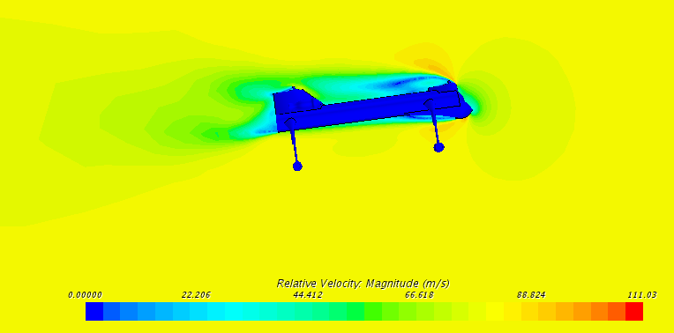

Figure 7: An example of the results derived from CFD analysis

As shown in Figure 7 above, the results generated by Star-CCM+ demonstrated which areas of the vehicle were creating the most drag and experiencing the most pressure. This allowed the design team to change the design using an iterative approach more effectively and decide where aerodynamic efficiency should be given up in favor of structural integrity, system integration requirements with container handling operations, or meeting alternative mission requirements.

The second SWaP code used throughout this project is referred to as a closing code. This is based on the sizing code explained above. This code substitutes out the weight correlation and iteration for an aircraft input weight. This allows for making small edits to the sized aircraft to see how the aircraft performs. Examples include using refined drag data provided from CFD and the impact of increasing cruise speed to reduce overall mission time. This code was also edited to analyse a variety of off-design missions to economically justify the production expense of the ISOLifter. These additional missions were discussed when presenting the aircraft to Boeing during the preliminary design review.

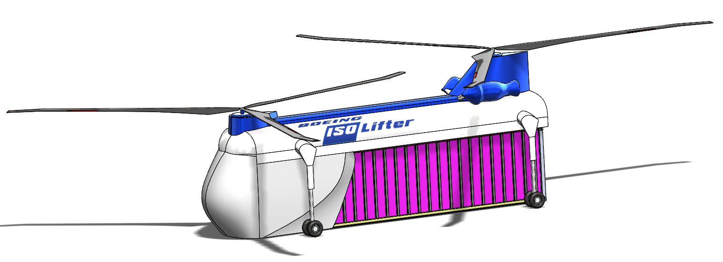

Figure 8: The final design of the Boeing ISOLifter

After multiple trade studies and design iterations, the picture above represents the final design of the vehicle: the Boeing ISOLifter. This section will detail a few of the design decisions the team made in order to reach the final product specifications.

One of the first decisions that made for the vehicle was the location of the container handling system (CHS) and how it would be oriented within the vehicle both while traveling with a container and while flying empty after container delivery. The team decided that the CHS should fit within the vehicle so as to decrease the aerodynamic effect of the system while flying without a load and to hold the top of the container flush with the bottom of the vehicle. This gives the vehicle a seamless aerodynamic mesh between the body and the payload, once again increasing the aerodynamic efficiency of the vehicle. Additionally, regulations on helicopter slung load operations encouraged the team to integrate the two systems as much as possible.

In a continued effort for better performance while flying, the team also performed a trade study to determine whether a mechanically and structurally more complex fairing to cover the front of the vehicle and the front of the container would be beneficial enough -- in terms of aerodynamic performance -- to justify the added complexity.

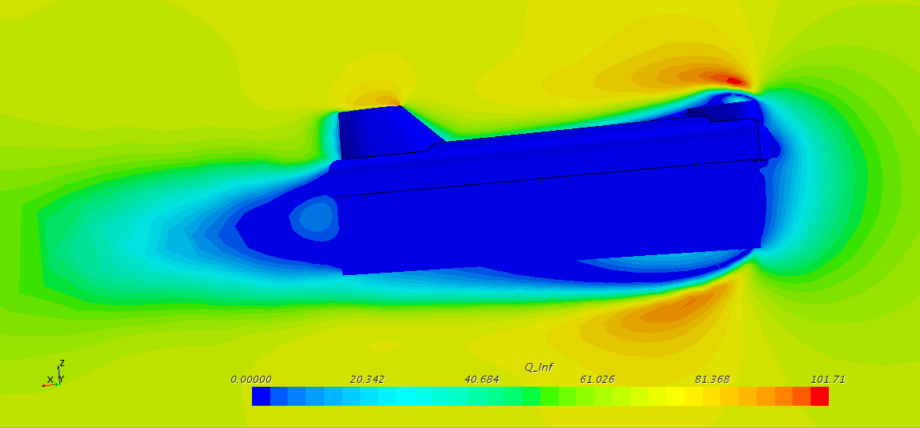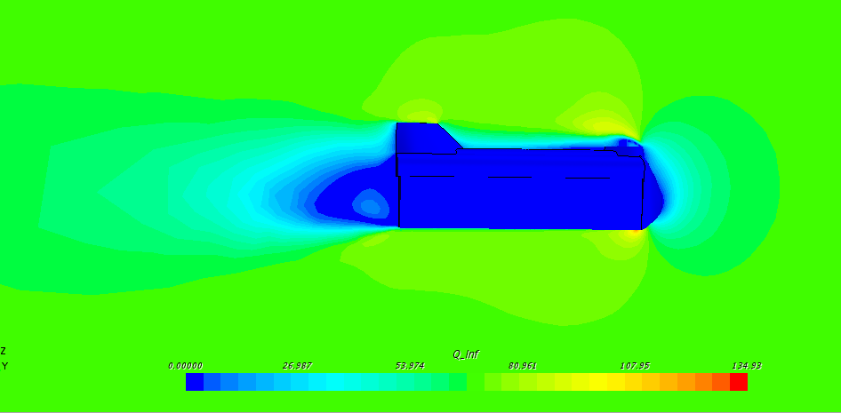

Figure 9: Comparison of CFD results for a vehicle without fairing (left) and with fairing (right)

Using Star-CCM+, the team found that adding a fairing which covers the front of the vehicle and container would have a coefficient of drag that is 0.06 less than a vehicle without a fairing (0.23 vs 0.29). Although the decimal is small, this is a significant decrease in the coefficient in drag, so the team decided to move forward with fairings in the design.

After deciding to move forward with fairings, the team was then faced with a design problem that involved finding a way to design a fairing that would minimally affect the drag of the vehicle while flying without a container yet easily and reliably deploy to positively impact the aerodynamic efficiency of the vehicle with a container. Researching emerging aerospace technologies, the team found a lot of promise in inflatable structures. Currently, companies such as Bigelow Aerospace are using inflatable structures to create capsules for the International Space Station, and ILC Dover is researching the effectiveness of inflatable wings. Based on current applications and ongoing research, the designers are confident that inflatable technology will be ready by 2040 to create inflatables which reliably deploy from to create a variety of fairing configurations necessary for the various missions stages of the Boeing ISOLifter. Inflatables will be more durable than fixed structures, can be stored at 1/10th the volume of the fully-inflated structure [12], and cost much less when compared to fixed or mechanical structures in terms of procurement and operational costs (weight penalties) [13]. In order to inflate the fairings, there will be a central pneumatic pump system with two-way valves capable of pumping all three fairings or individual fairings as needed.

The Boeing ISOLifter has a variety of fairing configurations which must be achieved by the inflatable fairings in order to fly with no payload, 20’ containers, and 40’ containers. These various configurations will be described in further detail below.

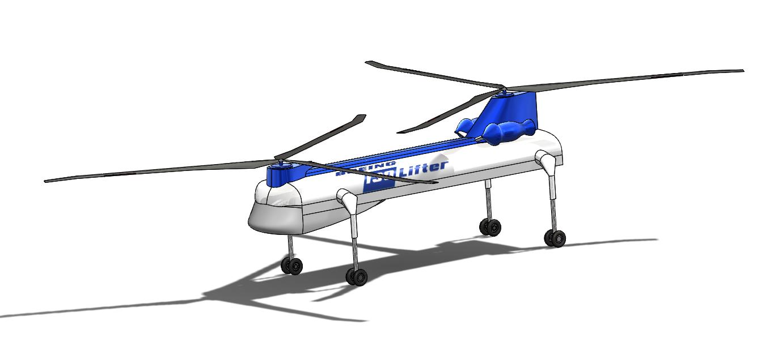

Figure 10: The Boeing ISOLifter without payload

Without a container, all fairings will be deflated. In order to deflate to a structurally sound shape without manual assistance, there will be a vacuum function within the central pneumatic system that will suck as much air out of the fairings as possible. The result is that a vast majority of the outer structure is supported by the rest of the material housed within. In order to reliably deflate into the required shape, the inflatable fairings will be made with an origami pattern, ensuring the fairing will always deflate according to a predesigned folding pattern to maximizes compactness and equipment lifespan [14]. The only fairing visible in this configuration is the forward fairing.

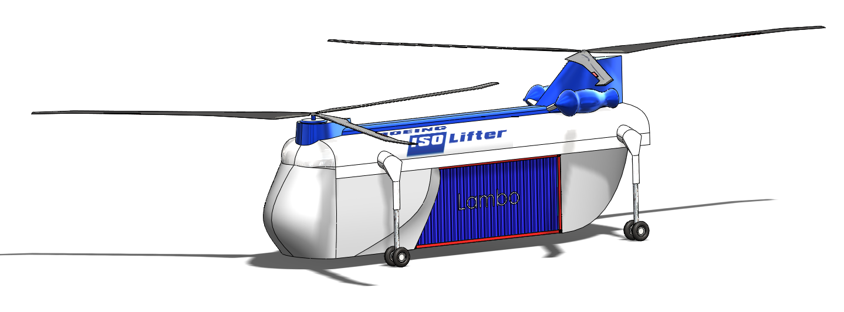

Figure 11: The Boeing ISOLifter with 20’ ISO shipping container

The fairing configuration when a 20’ shipping container is being delivered includes all three fairings being inflated. The forward fairing is the most important because it has the greatest effect on the aerodynamic efficiency of the vehicle and because it will take more loading than the remaining two fairings. With this in mind, the fairings will be made of a durable composite fabric material capable of withstanding punctures from knives or even bullets [15]. The front fairing will cover the front of the vehicle and extend down the sides to where the 20’ container begins. However, this fairing still leaves a 10’ gap between the back of the fairing and the front face of the shipping container. This space will be filled with a second fairing, located within the crane mechanism, that deploys when the CHS is retracted to the 20’ length. This fairing is not visible in the aircraft renderings. The third and final fairing is located to the rear of the 20’ container, and is stored in a similar manner to the second, hidden fairing, and will taper both horizontally and vertically. Because of its smaller size and additional room available at the rear of the vehicle, it is not visible in the empty aircraft configuration. The sweep of the rear fairing provides a downforce on the rear of the vehicle, and will be equal to the downforce created by the slope of the forward fairing as the vehicle travels.



Figure 12: The Boeing ISOLifter with 40’ ISO shipping container

The final configuration of the vehicle incorporates only the forward fairing. This design provides a much greater aerodynamic efficiency than a configuration that left the front, flat face of the shipping container exposed. From a basic design perspective, the vehicle used a Chinook helicopter as the base for the outer mold line. From there, changes to the design were made to incorporate a CHS housing that would keep the top of shipping containers flush with the bottom of the vehicle. A system of inflatable fairings was also created, connected by a central pneumatic pumping system, capable of catering to three specific configurations depending on the payload the ISOLifter is delivering. The team believes that this design represents an economical solution to the design problem presented for this project.

**Mission Overview**

The mission of this aircraft is to carry ISO shipping containers from a ship in port to a warehouse to bypass the port, time to load on a truck, and the final stretch of a containers journey on a truck. This mission involved three major phases including initially flying from the craft’s base to the ship, flying the legs between the ship and warehouse, and finally returning to base at the end of the day. The distance between the base and the ship is given at 25 nautical miles (NM). The Distance between the ship and the warehouse is given at 60NM. Also per requirements the aircraft must always have a fuel reserve of 20 minutes. This was modeled at a 20 minute loiter at the last part of the mission before landing. Below is a diagram of the mission segments.

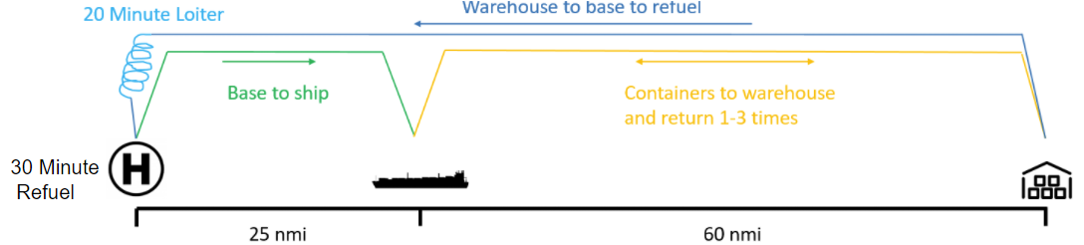

Figure 13: Mission Diagram

The 60NM between the ship and warehouse is to be flown once with a container from ship to warehouse then once without a container from warehouse to ship. This process could be repeated and was used as a trade study. Ultimately 2 trips was determined to be the most cost effective. Furthermore it was assumed that the ship lay on a straight line between the base and warehouse. This meant that the return flight from warehouse to base was the worse case scenario of 85NM.

From the market analysis above, the maximum cargo weight was taken to be 16,000 lbs, which does not include the tare weight of the container, which is approximately 8,000 lbs for a 40’ container [16].

**Mission Cost Parameters**

The objective function proposed by the customer was to minimize the total operating cost per pound of cargo transferred. The function compromises the total operating cost of delivering the ISO containers, divided by the pounds of transferred cargo, subject to the capability and constraints (requirements) listed below as well as the mission definition. The cost of the cargo delivery per aircraft-hr may be calculated via the equation below (development cost is assumed to be amortized into aircraft acquisition cost) [6].

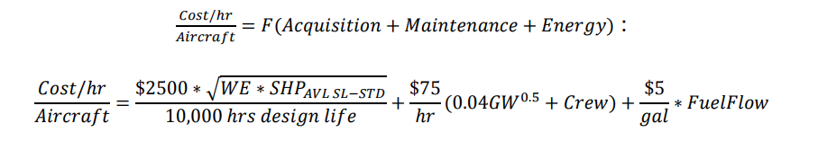

With the parameters defined as follows:

* Acquisition is defined by a simplified price equation based on Harris and Scully’s 1997 AHS paper, “Rotorcraft Cost Too Much”, and normalized by a typical design service life of 10,000 flight hours
* Maintenance is defined by a simplified weight-based man-hour/flight hour estimate (plus dedicated flight crew time) to maintain and operate the aircraft
* Energy is the average hourly cost to fuel the aircraft
* WE is the aircraft weight empty, in lbs
* SHP_(AVL SL-STD) is the installed horsepower available of the aircraft at sea level-ISA conditions
* GW is the maximum vertical takeoff gross weight capability of the aircraft, in lbs
* Crew is the number of crew needed to support the aircraft’s in-flight operation
* Flight and maintenance crew are priced at $75/hr per person
* FuelFlow is the average amount of fuel used in gallons per hour to operate the aircraft
* Aviation Fuel is priced at $5 per gallon

**Container Handling System**

The Container Handling System (CHS) is the largest removable subsystem of the Boeing ISOLifter. The CHS was designed with three key functionalities. In terms of the mission, the CHS would retract to either the 20-foot or 40-foot configuration for meshing capabilities with ISO containers. This will be accomplished through the use of a pair of rack and pinion actuators; these actuators attach to the actuation forks which are mounted into the aircraft crane bay. This fork allows both the winches and spreader to be adjusted at the same time and rate with minimum mechanical complexity. The result is a weight reduction on the spreader by removing the need for a second, independent actuation system. The shaft and winch make use of linear bearings to reduce friction along their path of travel. The mechanism is modeled in Figure 14.

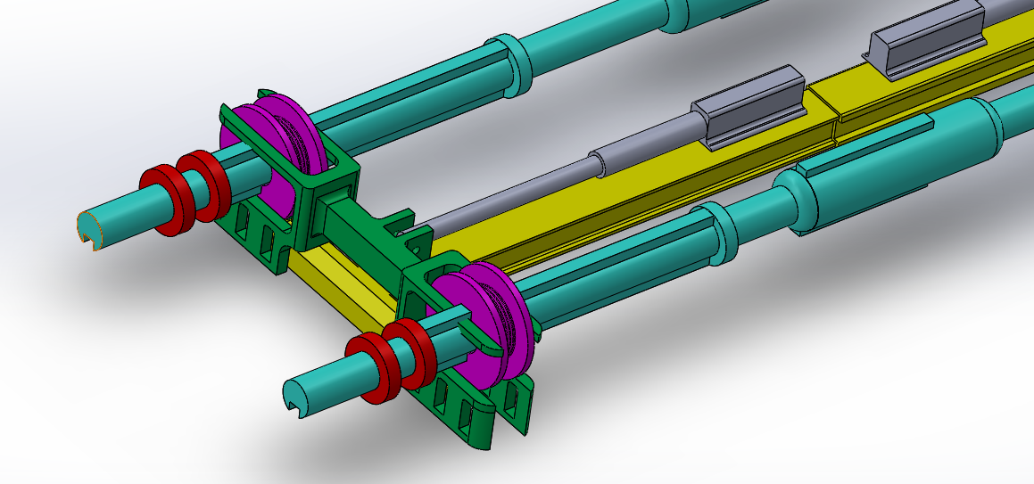

Figure 14: Linear actuation of CHS crane

The next functionality of the CHS is for the lowering and raising of the spreader. This is accomplished by inputting motor powers the two shafts, rotating the winches and raising/lowering the cables. In order to reduce spreader instability, the maximum cable extension will be limited to 15 feet. The cables are lowered at a slight offset angle (~10 degrees) to induce a ballast effect which increases spreader stability. The lower spreader design is shown in Figure 15.

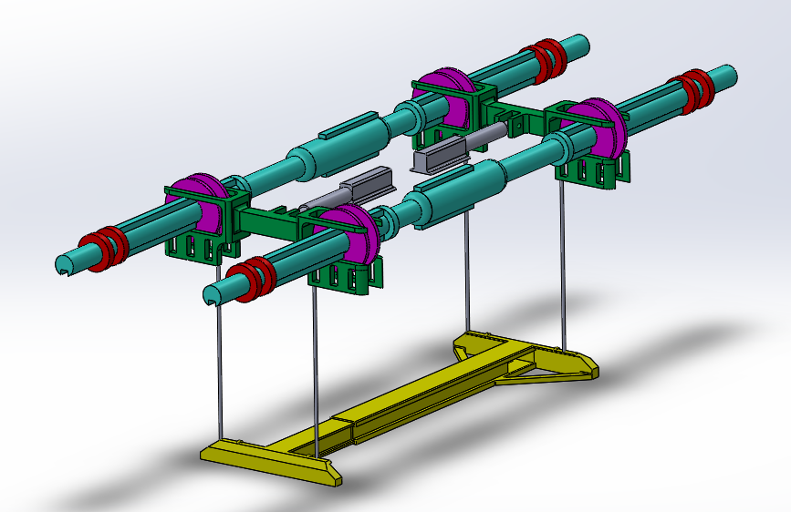

Figure 15: Container handling system (CHS) design with spreader deployment

For efficient container pickup off cargo ships, containers transporting high-value goods shall be equipped with the Universal Container Locking System (UCLS). The UCLS twistlock system connects the upper and lower twistlocks of the container together with a durable, mechanical connecting rod which eliminates the need for stevedores and significantly reduces operational risk during the customer-defined mission. When the top of the container is engaged by the container handling system twistlocks, the lower container twistlocks securing the container to the rest of the stack are simultaneously released [17]. This system is currently undergoing further certification and development, and will be compatible with all existing twistlock configurations to reduce potential barriers to adoption of the technology.

**System Integration**

Having system integration is of the utmost important in ensuring mission success. The CHS was dimensioned appropriately to fit within the confines that are the vehicle sizing, as well designed for an appropriate weight. The inflatable fairing must be inflated after the container has been meshed under the belly of the vehicle, as seen in Figure 16. Lastly, the fully integrated vehicle is shown in Figure 17.

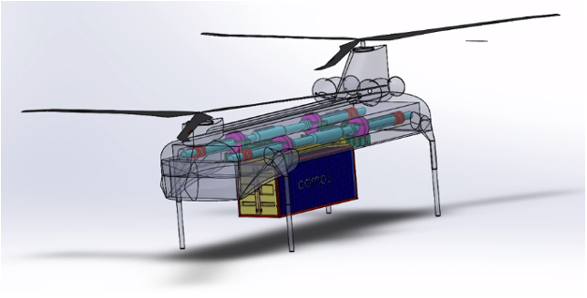

Figure 16: 1 TEU container pickup before fairing deployment

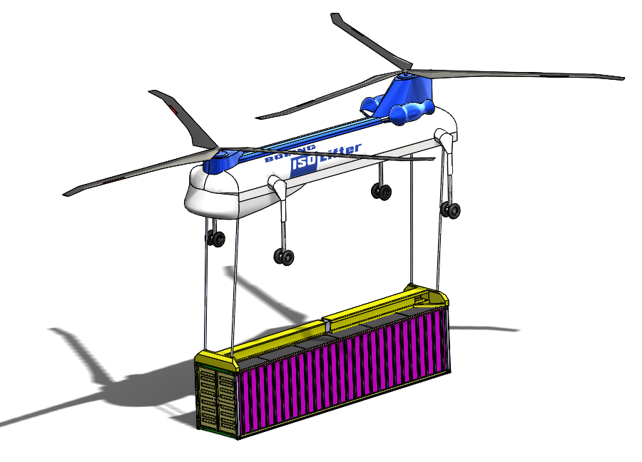

Figure 17: Integrated CHS design

**Lift / Propulsion / Aerodynamics**

*Blades*

The design of helicopter blades changes the dynamics of aircraft in various ways, such as: the lift, propulsion, and aerodynamics. Research led the team to finding which blade and airfoil design would best fit the vehicle needs. The mission was to maximize hoovering and lift, which was where the highest of the mission cost came from. This led the team to design for a high max coefficient of lift on the first half of the blade for Mach numbers of 0.0 - 0.4; and to design for a high lift over drag on the second half of the blade, for Mach numbers of 0.4 - 0.8. The methodology for the blade selection and blade design is as follows [18]:

1. Select a batch of airfoils that are both optimized and non-optimized for good performance across a wide range of mach numbers.
2. Test airfoils using STAR CM, analyzed data, and chose the best airfoil based on requirements.
   1. High lift at low mach numbers
   2. High efficiency at high mach numbers
3. Begin the blade design process
   1. Start with simply geometries and then add changes such as: twist and varying chord length.

Airfoil research led to the initial selection of these airfoils [18]:

* NACA 0012 - A baseline comparison
* NACA 23012 - A baseline comparison
* OA 213 - An airfoil designed for hoovering
* VR 12 - An airfoil designed for hoovering

The NACA series airfoils were chosen because they are not optimized for good performance over a wide range of Mach numbers and the OA and VR series are optimized for good performance over a wide range of Mach numbers.

Once the airfoils were selected, our next step was to begin to test with STAR-CCM+. STAR-CCM+ gave the lift and drag coefficient data over a range of Mach numbers and angle of attacks. From here, the lift to drag ratio, or efficiency of the airfoils was calculated and is shown in the Figure 18 below.

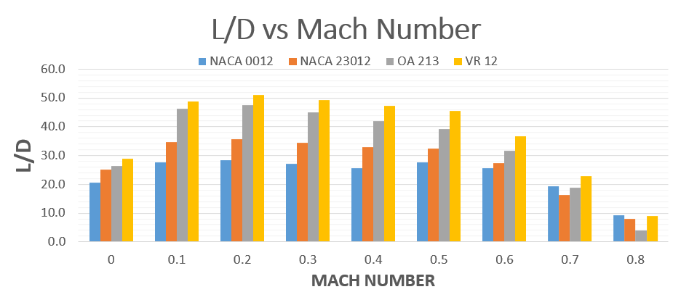

Figure 18: L/D vs Mach Number for rotor airfoil comparison

It is evident that the VR 12 outperforms the other airfoils and for that reason, the VR 12 was the selected airfoil.

Finally, with the aid of blade element theory and the CFD data obtained in the previous step, the blade design process could begin. The blade design process began with a simple design and then added an advanced iteration. Each small change increased the performance of the blade.

The first iteration of the blade started a non-changing chord length across the span of the blade and the entire blade was held at one angle of attack. The angle of attack the blade was held at was chosen using the CFD data that showed the average highest efficiency across all Mach numbers.

On the second iteration of the blade design process, twist was added to the blade. Adding twist to the blade is when the angle of attack of the blade changes from root to tip - the angle of attack at the tip is lower than at the root. The goal of adding twist to the blades is to maintain a linear lift distribution across the blade. Without adding twist, the lift forces at the tip of the blades could be strong enough for the blade to curve up violently.

Moving onto the third iteration of the blade design, this iteration focuses on changing the angle of attack and the chord length of the airfoil sections across the span of the blade. Changing the chord length of the airfoil sections allows for greater lift to be produced in the root sections of the blades and decrease the drag on the tip sections of the blade.

The final iteration of the blade design process was to highlight the 2040 technology. The blade would feature geometry that was optimized using very advanced codes and an aileron like control surface. The optimized geometry allows for the most lift to be produced while requiring the least amount of power [19]. Much like flaps are added onto wings of planes to increase the performance across a wider range of flight speeds, adding control surfaces onto helicopter blades will have the same effect on the blades performance [19]. The design iterations of the Boeing ISOLifter rotor blades are shown in Figure 18.

Figure 18: Different Wing Designs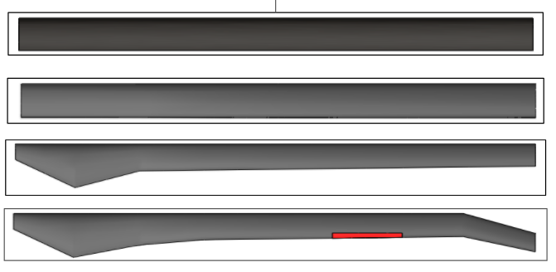

During the previous semester, the team used a sizing code to determine the optimal diameters for the rotors to be utilized. The result of those trade studies led to a decision that rotors with a diameter of 60’ would be optimal for performance, efficiency, and heavy-lifting missions. In order to incorporate these rotors into a tandem configuration that has a body that is 43’ long, the rotor hubs needed to be located as close to the ends as possible. In addition, pylons are necessary to stack the blades in a way that keeps the blades separated vertically by a distance of minimally three feet. This vertical distance was determined through studying the current Chinook design and using the legacy of the Chinook to drive that design decision. In order to achieve this distance, pylons had to be incorporated into the design. From a top view, the pylons resemble a neutral airfoil to increase aerodynamic efficiency, and from the side the separation and angles between the pylons allows for two 60’ diameter rotors to spin without interference from the pylons.

*Powerplant Selection - BSFC*

Due to the unsure readiness of electric motors by the target year 2040, the team decided to utilize turboshaft engines to power the rotors on the ISOLifter aircraft. The main engine parameter used in the SWaP calculations was the BSFC. This parameter was extrapolated to the year 2040 by adjusting the maximum turbine inlet temperature of the engine in the team’s engine code using Engineering Equation Solver (EES) software. The maximum turbine inlet temperature is the value which ultimately sets the efficiency of the engine. Below is a plot produced by the University of Virginia, which shows temperature plotted vs. the year in which the technology should be available and used efficiently in mass production scales [20].

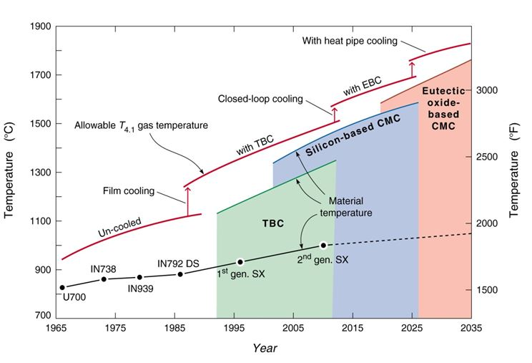

##### Figure 19: Past and predicted materials, coatings, cooling concepts and turbine inlet temperatures

For further clarification, the material in green represents current super alloys with Thermal Barrier Coatings (TBC). This material is able to withstand very high temperatures. However, these coatings are very expensive to apply and require very regular maintenance. Looking into the future of turbine blade materials, companies are beginning to mass produce Ceramic Matrix Composites (CMC) which can withstand even greater temperatures than their super alloy counterparts, while having only ⅓ the density of these metals. From here, the team used a turbine inlet temperature of 3270 ºF, which is the predicted maximum operating material temperature of Eutectic-oxide-based CMCs by the year 2035 [21]. This value was inputted into the engine EES code to calculate the BSFC of an engine for differing values of the compressor pressure ratio. This relationship was then plotted in Excel. A few actual turboshaft engines were also included in order to show the accuracy of the calculations.

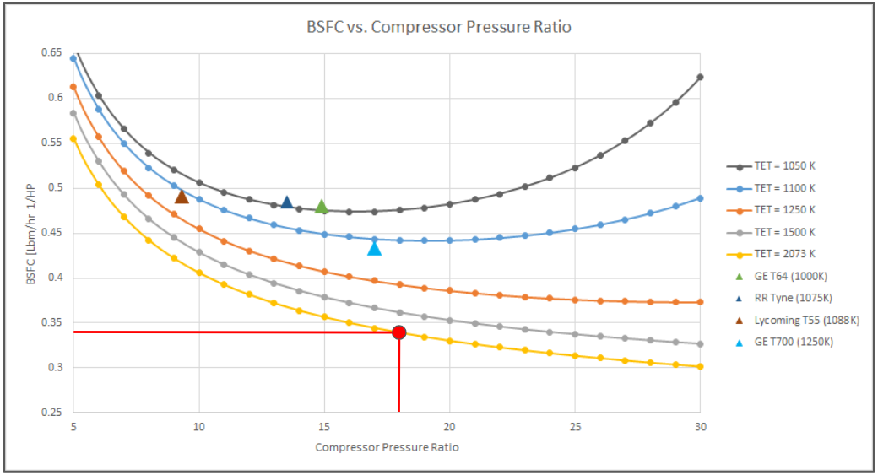

##### Figure 20: Turboshaft BSFC plotted vs. compressor pressure ratio. BSFC of 0.34 selected

##### From the image above, a compressor pressure ratio of 18 was used, which is a value that will absolutely be attainable for turboshaft engines of the required size by the year 2040. Also, the plotted curves showed an error of 3.65% when compared to values of actual engines. This confirms the accuracy of the extrapolations and shows that the curve plotted for the inlet temperature at 2073 K should be rather accurate.

Beyond BSFC calculations, the team observed current trends in the propulsions industry as well. Current engine development programs were explored for possible engine candidates. Currently, the Improved Turbine Engine Program (ITEP) by GE is focusing on improving existing turboshaft engine performance (engines specifically designed for military heavy lifting operations). The GE T408 Engine is undergoing testing and has been selected as the powerplant for the Sikorsky CH-53K King Stallion [22]. It will use three of these turboshafts and have the ability to lift external loads of up to 27,000 lbs. Based on market analysis and SWaP calculations, a 24,000 lbs will be used through aircraft design. of cargo, and will necessitate around 11,000 SHP. Below is a table which compares the T408 to GE’s current heavy lifting engine, the T64. This comparison displays the significant improvements in engine performance over ~40 years of changes and improvements.

Table 3: Comparison of GE’s T64 and T408 turboshaft engines [23, 24]

|  |  |  |
| --- | --- | --- |
| Performance Parameter | Current (GE T64) | Future (GE T408) |
| BSFC (lb/hp·hr) | 0.48 | 0.39 |
| Max Power Output (shp) | 4,330 | 7,500 |
| Power-to-Weight (shp/lb) | 6.01 | 6.80 |
| Overall Pressure Ratio | 14.9:1 | 18.6:1 |

For the Boeing ISOLifter aircraft, the team has plans to use a future variant of the GE T408 engine. Its current BSFC is already fairly close to the projected value of 0.34, and it utilizes carbon matrix composites (CMCs) in its turbine section. In order to achieve the horsepower requirement of 11,000 SHP, the aircraft’s counter rotating blades will be powered by two engines, each contributing 5,500 SHP. This amount of power is enough to power the aircraft for its designed mission with a 10% cushion. This is to account for any further inefficiencies or the need to power aircraft subsystems and container handling system operations which are not supported by the aircraft’s structural battery.

**Structures & Landing System**

In order to minimize the aerodynamic drag that will be created by four fixed, spider-like landing gears, the sponsons and the pneumatic cover of the landing gears are shaped like neutral airfoils. This shape will decrease the drag force while also neutralizing any lift force that may put unnecessary loads on the sponsons of the landing gear.

The fixed, 4-wheel landing gear configuration was analyzed in ANSYS to ensure compliance to the 1.5 safety factor required by FAR Section 29 requirements under limit load drop tests. In order to perform an accurate analysis, the dynamic loading was converted to an equivalent static load using an empirically-derived dynamic load factor (DLF) [25]. To ensure landing gear compliance under the worst-case conditions, the maximum gross weight with a loaded 2 TEU container was used in the equation below. The 1.5 factor of safety was applied in addition to these calculations. The result is a static structural load of 31,134 lbs per wheel.

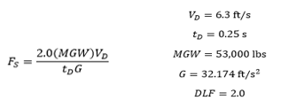

Based on a material selection of structural steel, the maximum equivalent stress is 38.4 MPa and the maximum shear stress is 19.9 MPa. These are both well below the material yield strength. Maximum deformation is shown as 0.758 mm, indicating that further detailed design of this subsystem could look into lightweight materials such as carbon fiber composites, lighter metal alloys, or alternative geometries for the landing gear components to reduce weight while maintaining the required factor of safety.

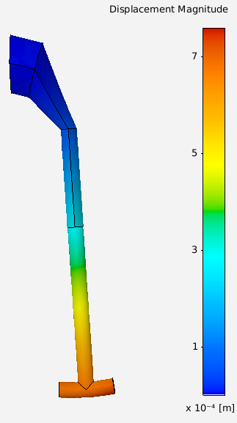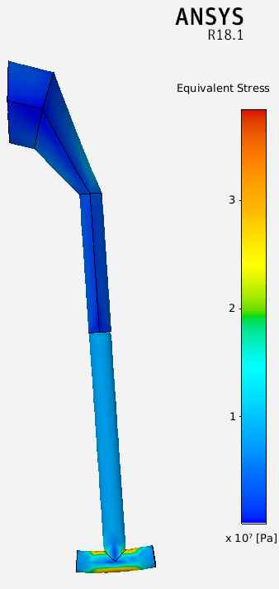

Figure 21: Landing gear displacement and equivalent stress magnitude

A fixed landing system, however, was not the only setup the team investigated. A retractable version of the landing gear was also designed and tested in CFD. Based on STAR-CCM+ data, a small decrease in the aircraft’s coefficient of drag is achieved when the landing gear was rotated up to the aircraft’s structure. Below are images of the two different tested landing gear systems.

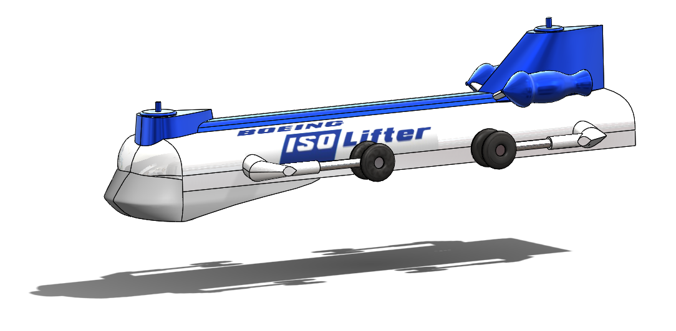

Figure 22: The ISOLifter with fixed landing gear (left) and retractable landing gear (right)

Even with the small decrease in drag coefficient, it was very difficult to find any sort of legacy aircraft weight correlation in order to perform SWaP analysis. Since the rotating landing system would be significantly heavier (with the addition of hydraulic systems, structural supports, motors, bearings, etc.), require more maintenance, and taking into account the vehicle’s relatively slow optimum cruise velocity (~140 kts), it was decided that the simpler fixed landing system would be utilized.

**Controls System**

The control system of the vehicle was designed to mimic how a real longitudinal control system works on helicopters. No control surfaces were planned on being added and the team made the decision to develop a control system that articulated the blades to control the vehicle. The longitudinal control system works as follows:

1. Perform angle of attack sweeps in CFD
2. Input aerodynamic data into control code
3. Use a PID controller to analyze response times

The main working principle for the longitudinal control system is differential thrust. Once the differential thrust is known that will balance out a disturbance moment, the angle of attack of the front and rear blades can be changed to match the required thrust. Below is a figure of how the control system works and how the front and rear rotors change their respective angles of attack to balance out the aircraft.

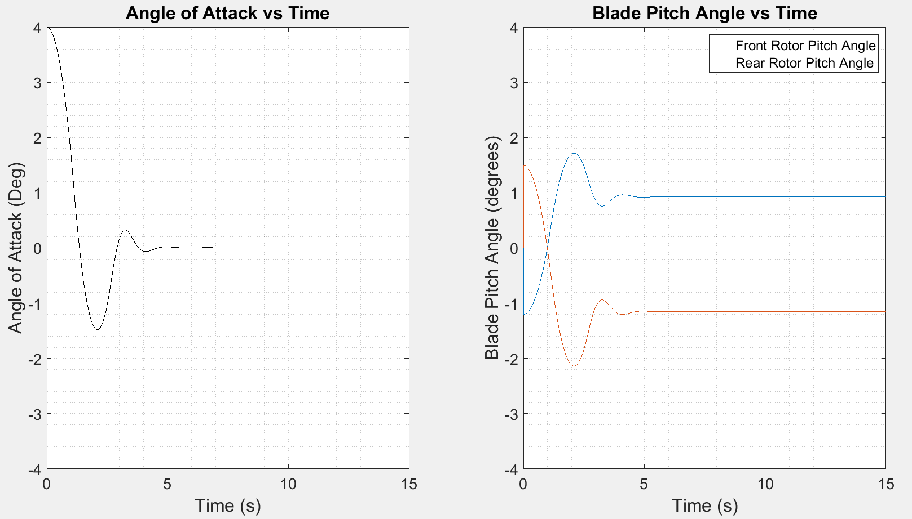

Figure 22: PID Controller Outputs

**Flight Guidance System**

The flight guidance system is the only system not currently tested at the required scale. The autonomous system will have to operate several phases, some riskier than others. Therefore require a supervisor who looks over a fleet of ISOLifter vehicles. The first phase of flight will be take-off, this will require having a computer who can take hoover, accelerate, and finally rise to appropriate altitude for the mission. The next phase will have to be for one of navigation. The autonomous system will use third-party reports of terrain and weather to form and navigate an appropriate fly path that minimizes cost while allowing for maximum safety. Avoiding in-air collisions with other aircraft is the biggest of risks when looking at the flight path. The 2020 Automatic Dependent Surveillance - Broadcast (ADS-B) Out system will allow the autonomous system know where other aircraft are. The flight guidance computer will know to circumvent around or under/above. ADS-B Out is expected to be mandated by 2040. This will allow for other aircraft to be aware of future autonomous aircraft [26].

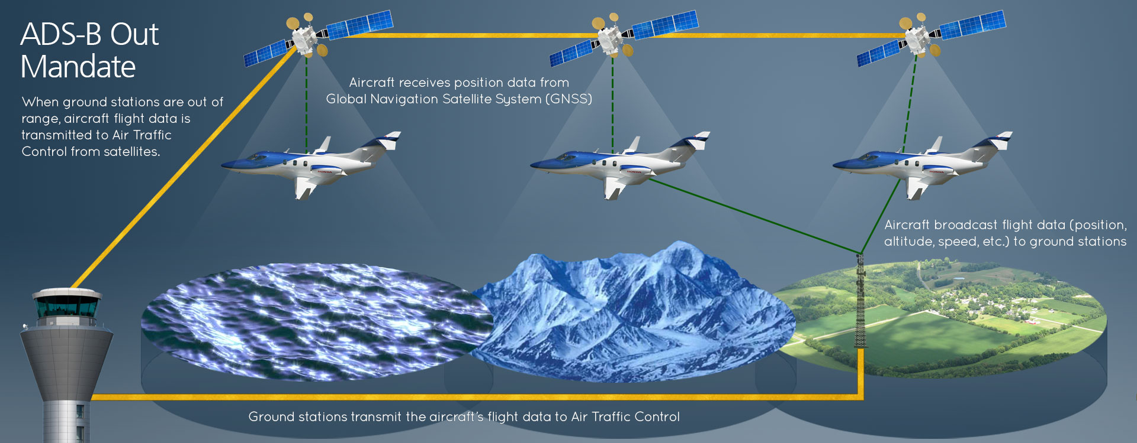

Figure 23:ADS-B Out/In for Aircraft Collision Avoidance [26]

The next phase will be picking up the container. Dependent of the aircraft, the CHS will be controlled through a form of autopilot specific to the extraction of the ISO container it is retrieving. Onboard lazers will use locating technology to pinpoint the location of the twist locks and insure correct meshing. Although at high level, there will be significant development for the pinpoint accuracy needed for container handling system and container meshings.

The overall autonomous system will encompass two parts. The first being onboard sensors that act independently of outside data and information. The second part will be connectivity between outside data and these onboard sensors. These two sets of data will have to cross-check their control commands to ensure safety of control commands. Redundancy of each these stand-alone systems is still required, despite this double redundancy. Having two forms of decision making, allow for cross-check, ensuring a safe successful flight.

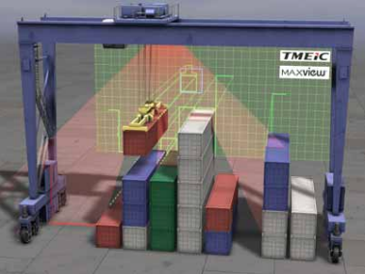

Figure 24: Laser System for Container Meshing [27]

The team decided to give the aircraft an initial 30-year benchmark for operations. The system will be an architecture system. This will ensure that the aircraft can be adapted to any regulatory mandates. Similar to the ADS-B mandate, out system will be ready for new software and hardware.

**Final Performance**

Table 4: Final Aircraft Performance Specifications

|  |  |
| --- | --- |
| **Parameter** | **Standard Operation**  **(3 Missions/Day)** |
| **Max Gross Weight** | 57,312 lbs |
| **Max Expendable Weight** | 24,000 lbs |
| **Max Range** | 290 NM |
| **Cargo Delivered per Day** | 96,000 lbs |
| **Cost/Pound of Cargo** | 65￠/lb |
| **Operating Time per Day** | 11.16 hrs |
| **Engine Selection** | 2x GE T408 Variant  (5,500 SHP each) |
| **Engine BSFC** | 0.34 lbm/hp hr |
| **Drag per Configuration** | 0.259 (No Container)  0.220 (1 TEU Container)  0.298 (2 TEU Container) |

**Mission Risk Mitigation**

This mission has part to it that are of high risked and require careful planning. The most probable risks are highlighted below in a consolidated list. Table 5 below outlines many risks and briefly explains a mitigation plan.

Table 5: Mission Risk Mitigation Summary

|  |  |  |  |
| --- | --- | --- | --- |
| **Description of Risk** | **Category** | **System Impact Classification** | **Plan to Mitigate** |
| Loss of Autonomous Control | A/C Safety | Low | Two independent systems, redundant sensors, and redundant cyber security |
| Engine Inoperative | A/C Safety | Low | Multiple engines with loiter capability with 1 engine inoperable |
| Poor Weather | Mission | Medium | Reroute to safety by monitoring local weather, fly/no fly conditions |
| Collision with  Terrain or Other Craft | Safety | Medium | ADS-B tracking, terrain and traffic sensing and avoidance |
| Cargo Instability | Cargo Safety | High | Controlled long descent, pickle load |

Loss of autonomous systems is not a dire situation to the aircraft or the payload, but would require landing. Like most aerospace systems, the FDAL A-level [28] system would require triple redundancy for airworthiness flight. Not only would the aircraft require double redundancy, it would have a way to check its proposed autopilot movements. Onboard sensors would be the first way that the aircraft checks its controls. It would check its controls with a third party, such as ADS-B Out/In to ensure that its control laws were safe. If the systems show faulty commands, a remote operator would take control and make real-time decisions as to what the aircraft should do. Losing one system would not be the end of the aircraft and payload, but it would be the end of a mission, requiring the aircraft to return to base or land at the closest safe zone away from population centers.

A one engine inoperative event is a mission-ending situation for the aircraft, but risks have been minimized by strategic power plant selection. Having two engines allows the control system to reduce aircraft flight to a loiter and return to base, assuming the engine out occurs during cruising flight. In the worst-case event, an autorotation landing maneuver could be performed and the payload would be dropped to reduce power required. The ISOLifter requires 3600 SHP to loiter with a 2 TEU container payload, and one of the GE T408 variant engines can produce 5500 SHP. This results in a minimum one engine inoperative velocity of 45 knots. The power vs velocity curve for the aircraft in its maximum gross weight configuration is found using the closing code, and shown in Figure 25.

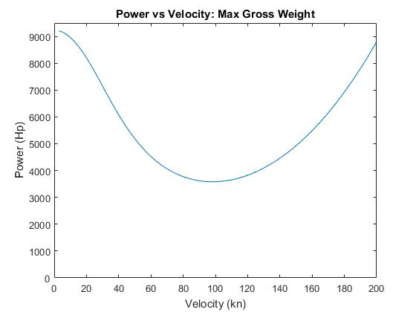

Figure 25: Power versus Velocity: Max Gross Weight

Poor weather can be circumvented with appropriate weather radars. Collision with other aircraft can also be avoided by incorporating 2020-mandated ADS-B Out, along with ADS-B In [24]. Terrain can also be avoided as it is stationary. Furthermore, the majority of weather and terrain can be ruled out through pre-flight path developments.

Lastly, aircraft instability is of the utmost importance with an expendable payload of 24,000 lbs being hoisted and lowered into place by cables. An analysis of the design team’s instability solutions is below.

Table 5: Instability Resolution QFD

|  |  |  |  |  |  |  |  |  |
| --- | --- | --- | --- | --- | --- | --- | --- | --- |
| **Solution**  **/**  **Parameter** | **Cost and Weight**  **35%** | **Container Safety**  **(High Alt.)**  **5%** | **Container Safety**  **(Low Alt.)**  **10%** | **Aircraft Safety**  **10%** | **Ground Safety**  **25%** | **Reliability**  **10%** | **2040 Technology**  **5%** | **Final Score** |
| Parachute | 6 | 9 | 1 | 9 | 3 | 6 | 1 | 4.95 |
| Water Inflatables | 1 | 1 | 1 | 9 | 1 | 6 | 3 | 2.4 |
| Landing Cushion | 1 | 3 | 6 | 6 | 1 | 3 | 6 | 2.55 |
| Drone Hybrid CHS | 1 | 9 | 9 | 6 | 9 | 3 | 9 | 5.3 |
| Clean Drop | 9 | 1 | 1 | 9 | 1 | 9 | 1 | 5.4 |
| **Controlled Long Descent** | **6** | **1** | **6** | **3** | **9** | **9** | **1** | **6.25** |
| Retro Rockets | 1 | 9 | 6 | 6 | 1 | 3 | 9 | 3 |

Hovering operations pose the highest degree of danger for aircraft instability, especially when picking up or delivering a shipping container. Data collected by the International Helicopter Safety Team from 2005-2015 shows that 21% of accidents due to pilot error and 55% of accidents due to flight regulation violations occur during flight below a minimum safe altitude [29]. This guided the team to develop a list of potential solutions for cargo instability at low altitudes. The QFD chart (Table 5) above led to the best solution being a controlled long descent system. With 65 feet of composite cables at each corner of the CHS, the aircraft is capable of releasing the total length in the event of payload instability. Securing the container to the aircraft with this design allows for emergency drops of the load at designated locations while reducing overall damage to the container and surrounding area because the payload is effectively dropped from a lower height. The second best option is to have a clean drop, were the payload is simply released from the CHS through the use of pyrotechnic bolts.

**2040 Risk MItigation**

The aircraft is designed to incorporate various 2040 technologies. Although these 2040 technologies do not concern the high level design of the Boeing ISOLifter, it is important to plan and mitigate for their failure to come to fruition. Below in Table 6, the team outlines these 2040 technologies and seek for way to remedy.

Table 6: 2040 Risk Mitigation

|  |  |
| --- | --- |
| **Technology** | **2040 Risk Mitigation Plan** |
| Composite Cables | * Unique application of proven technology * Traditional cables → increased CHS weight |
| Structural Batteries | * Only power CHS subsystems * 10% excess power from turboshaft engines |
| Engine Performance - BSFC | * Re-evaluate economics of mission profile * Use most efficient engine in production by 2040 |
| Inflatable Fairings | * Inflatables proven in aerospace (ILC Dover, Bigelow) * Fixed or mechanical fairing replacement |
| Autonomous Controls | * Design is contingent on autonomous controls in 2040 * Otherwise, remotely piloted |

The container shipping industry is typically not concerned with the weight of their equipment and the systems they use to accomplish day-to-day operations. Which is not the case for the aerospace industry where there is cost-savings through the reduction of system weight. Cable weight reduction in the CHS would be essential to these cost-savings. As society moves toward vertical urbanization, elevators of the future which will require these composite cables and which drive for research for implementation. These composite cables already exist today and are proven to work, but are not yet in industries [30, 31]. These cables can still be improved on and await for further application. As it reckons in the aerospace industry, certification is required from different entities for airworthiness and operation. Thus the battle with implementing composite cables before 2040 is not from the development, but from the certification of these cables [32]. Furthermore, these cables can, and should still be developed further to continue to increase cost savings in day-in-day-out operations. If composite cables were not developed and certified by 2040, the designers would see an increase in aircraft weight and operational costs.

Similar to composite cables, other 2040 technologies are also in working and operating states but require further development and certifications. Structural batteries have been proven in lab settings, with energy densities of 0.010 kWh/kg which is significantly lower than current Li-ion battery technology. However, researchers expect future designs to reach densities of 0.175 kWh/kg. The key development needed to see implementation of this technology by 2040 is the development of matrix materials with better ionic conductivity and incorporated cathodes [33, 34]. Missing structural battery marks is not a significant concern, as the expected 189 kWh of energy storage capacity will only power non-flight critical CHS operations. Additionally, there is a 10% excess power factor built into the turboshaft power. Some of this accessory power would be used to operate the CHS if structural batteries were not developed by 2040. Missing the engine BSFC projection would also affect mission cost, but the aircraft plans to operate with the most fuel efficient engine in the market that could produce enough power to operate the vehicle. The most significant change in the vehicle with the inflatable fairing design not being certifiable or fully developed. Not having fairings would require the design team to change to a mechanical fairing, and at a worst case scenario a fixed fairing, both of which would increase weight and decrease the adaptability of the ISOLifter platform.

The most ambitious 2040 technology is is autonomous flight guidance system. This would require various certification authorities and much needed development to have ready by 2040. So much, that some may believe it not possible, there are market and environment drivers that will lead to the development of these autonomous systems. Vertical Urbanization will be a certainty with an estimated 2040 population of 9,157,233,976 [35]. The transportation company, Uber, has started the project, Elevate to address the need for commercial VTOL with the possibility of operational vehicles in 2020 [36]. Furthermore, a shortage of pilots will drive a market for autonomous certification by 2040, as these urbanized areas will not have enough pilots to operate, and the with the average human not being able to operate in these adverse environments [36]. Missing these certification goals and development would require for a remote operating pilot, as redesigning for a cockpit will eliminate it from future markets when autonomous vehicles are certifiable its and operable.

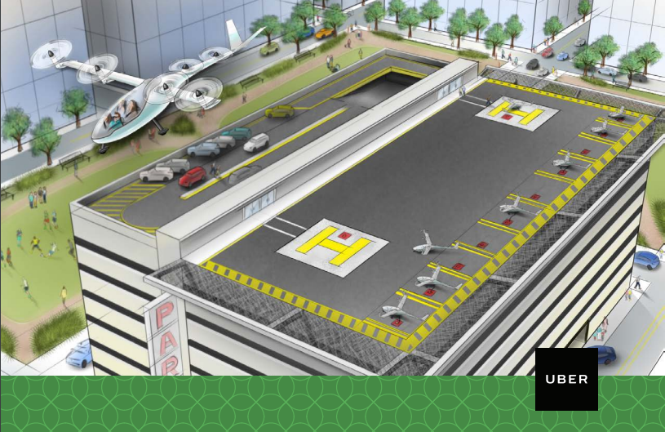

Figure 25: Vertical Urbanization and commercialized VTOL - Uber [36]

**Off-Design Variations**

To ensure continued customer demand for the Boeing ISOLifter vehicle platform and profitable vehicle operations throughout its 30 year expected lifespan, the design team examined four off-design versatility cases outside of the customer-provided mission: humanitarian mission support, pseudo port operations, empty container repositioning, and expedited refueling near ports. Operations during each of these scenarios will be discussed in detail below.

*Humanitarian Missions*

When natural disasters such as hurricanes strike coastal regions, the roads and shipping lanes which make up the backbone of many transportation infrastructures are often destroyed or at least severely limited. In these circumstances, humanitarian support is often present, but response is slowed due to debris, lack of electricity, fuel, or other resources. When paired with a retrofitted 500-700 TEU container ship, the ISOLifter can overcome these issues and provide efficient humanitarian support regardless of ground conditions. In this scenario, the container ship would approach the affected coastal area or island with the ISOLifter on its ship helipad. The containers on the ship would be a mix of humanitarian aid supplies, food, water, modular container homes, portable solar panel arrays, and tanks with jet fuel for autonomous aircraft refueling. With the ability to position containers in strategic locations, emergency response areas could quickly be established throughout the region. The team used the island of Puerto Rico after Hurricane Maria as a case study for this example presented during the project PDR.

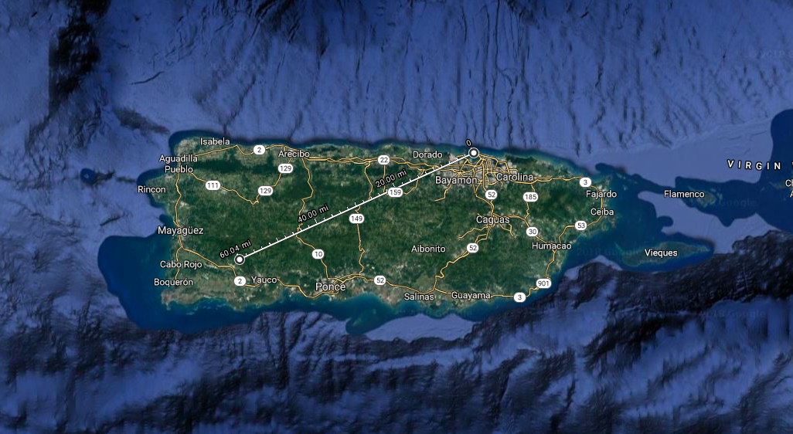

Figure 26: Customer range requirement provides total island coverage of Puerto Rico [38]

*Coastal Pseudo Ports*

Many of the world’s shipping lanes closely follow the coasts of each continent for some duration before departing across an ocean. Because of these standard logistics, the Boeing ISOLifter could be used to deliver high-value goods to cities near the coast which are enroute to a container ship’s final destination without the ship ever stopping for the delivery. Instead, the vehicle would pick up the selectively-located container, fly toward the coast to the warehouse location, complete the container drop-off, and return to the ship’s new location using existing GPS locator technology. As Figure 27 shows, this business model could be particularly valuable on the East and West coasts of the United States, as well as the Gulf region where a high density of container shipping lanes are present:

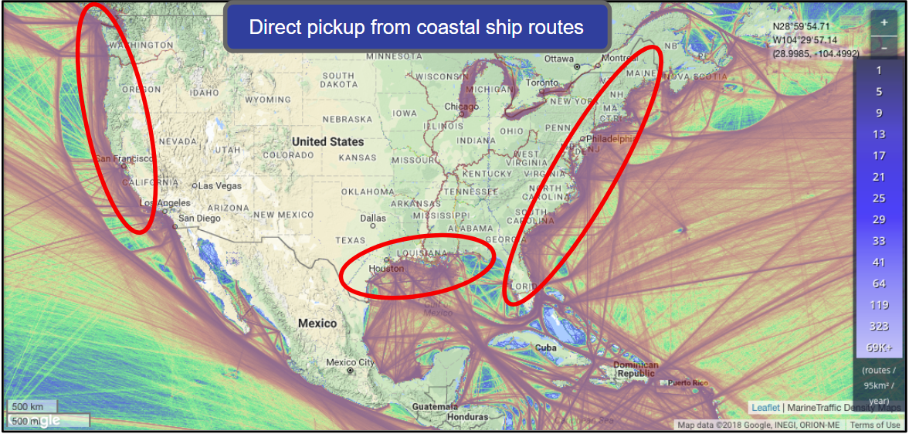

Figure 27: US container shipping lane density map [39]

*Expedited Port Refueling*

Taking a unique perspective on the customer’s original mission requirements, the ISOLifter could begin operations each day by flying from the aircraft base to the port with a 20’ ISO fuel container carrying enough fuel for the mission cycles to be completed that day. In this scenario, the amount of time required for refueling operations is significantly reduced, and the number of missions completed in the customer-specified 14-hour operating day can be increased from three to four (increase from six containers delivered to eight containers delivered). Based on the fuel container manufacturer and the total fuel volume required by the aircraft, the design team also expects the refueling time can be reduced from 30 minutes to 20 minutes [40, 41]. Below is a performance trade study comparing this operating plan with the standard mission, in which a savings of five cents per pound of cargo is achieved.

Table 7: Expedited Port Refueling Trade Study Results

|  |  |  |  |
| --- | --- | --- | --- |
|  | Standard Operation  (3 Missions/Day) | 30 Minute Port Refueling  (4 Missions/Day) | 20 Minute Port Refueling  (4 Missions/Day) |
| Time | 11.16 | 12.84 | 12.18 |
| Trips | 6 | 8 | 8 |
| Cargo Delivered | 96,000 lbs | 128,000 lbs | 128,000 lbs |
| Total cost | $62,442 | $79,720 | $76,321 |
| Cost per pound | 65￠/lb | 62￠/lb | 60￠/lb |

*Container Repositioning Logistics*

The repositioning of empty shipping containers back to the port or alternative storage location is a complex, costly issue in global logistics that amounts to a $16 billion per year industry [42]. Depending on the port location and import-export trade balances, it can be more cost effective to manufacture new containers than to relocate existing ones. Using a 2040 technology being developed by the company Staxxon, the Boeing ISOLifter can help relieve the large demands that empty containers place on port infrastructures while providing customers with a port-to-port, round-trip solution with lower overall usage costs. Using collapsible shipping container technology, the design team believes that by 2040 it will be commonplace for up to five empty containers to be returned in the same volume as a single loaded container [43].

A performance trade study was conducted using an altered version of the closing code to assess the economic feasibility of this concept, using a return of three unloaded containers for each return trip to the port. Additional hover stages were added to account for the empty container drop-off at port, and a small transition back to the container ship at a lower altitude was also included. A set of three empty containers were used because, at approximately 8,000 lbs each, the maximum expendable container weight was reached. The results of this trade study, compared to the customer specified mission, are included below. Note that empty container returns are assessed at a given $/mile rate, similar to inland truck transportation of ISO containers, and include the impact of container holding fees and other delay charges [44].

Table 8: Empty Container Repositioning Trade Study Results

|  |  |  |  |
| --- | --- | --- | --- |
|  | Standard Operation  (3 Missions/Day) | 6 Empty Containers/Mission  (3 Missions/Day) | 6 Empty Containers/Mission  (3 Missions/Day) |
| Time | 11.16 | 11.25 | 11.25 |
| Trips | 6 | 6 | 6 |
| Cargo Delivered | 96,000 lbs | 93,000 + 18 Empty Returns  ($3/mile return fee) | 93,000 + 18 Empty Returns  ($4.50/mile return fee) |
| Total cost | $62,442 | $65,607  -$4,050  $61,557 | $65,607  -$6,075  $59,532 |
| Cost per pound | 65￠/lb | 71￠/lb (no return profit)  66￠/lb (with return profit) | 71￠/lb (no return profit)  64￠/lb (with return profit) |

**Sources**

[1] “The Wright Brothers”, N/A, <https://airandspace.si.edu/exhibitions/wright-brothers/online/fly/1903/>

[2] “First Mail”, 2011, <https://postalmuseum.si.edu/collections/object-spotlight/india-air-mail.html>

[3] “The Beginning Air Warefare”, 2008, <http://www.eyewitnesstohistory.com/airwar1914.htm>

[4] “World’s First Commercial Flight”, 2012, [https://www.space.com/16657-worlds-first-commercial- airline-the-greatest-moments-in-flight.html](https://www.space.com/16657-worlds-first-commercial-airline-the-greatest-moments-in-flight.html)

[5] “Ship and ISO containers”, 2018, [http://www.almarcontainergroup.com/wp-content/uploads /2018/03/cheapest-shipping-containers-for-sale-02.jpg](http://www.almarcontainergroup.com/wp-content/uploads/2018/03/cheapest-shipping-containers-for-sale-02.jpg)

[6] Lacy, Roger et. al, “Container Lifter 2040 Project: Rules of Engagement White Paper,” Containerized Cargo Density Plot, Boeing Military Aircraft, 2017, PDF.

[7] “Container Dwell Time Metrics for Port Efficiency & Velocity,” Pacific Merchant Shipping Association, 2016, [http://www.pmsaship.com/pdfs/PMSA%20Press%20Release%20Container%20D well%20Time%2 011-17-16.pdf](http://www.pmsaship.com/pdfs/PMSA%20Press%20Release%20Container%20Dwell%20Time%2011-17-16.pdf).

[8] “Transit time difference between LCL and FCL,” FFQO US, 2015, [https://www.freightforwarderquote online.com/news/transit-time-difference-lcl-fcl/](https://www.freightforwarderquoteonline.com/news/transit-time-difference-lcl-fcl/).

[9] “Port-level Imports,” United States Census Bureau, 2017, [http://usatrade.census.gov/Persp ective60](http://usatrade.census.gov/Perspective60).

[10] “National Motor Freight Classification Table,” 2013, [https://www.napma.net/national-motor-freight- classification-table/](https://www.napma.net/national-motor-freight-classification-table/).

[11] “How to determine my freight class?” BAM Freight, 2017, [http://www.bamfreight.com/turning- point-blog/how-to-determine-my-freight-class](http://www.bamfreight.com/turning-point-blog/how-to-determine-my-freight-class).

[12] “BEAM”, Bigelow Aerospace, <http://bigelowaerospace.com/pages/beam/>

[13] “Morphing Inflatable Wing Development for Compact Packaged Unmanned Aerial Vehicles”, ILC Dover, <http://citeseerx.ist.psu.edu/viewdoc/download?doi=10.1.1.124.6746&rep=rep1&type=pdf>

[14] “MIT Researchers Develop Origami Inflatables”, Super-Releaser [http://superreleaser.com/ blog/2017/1/31/mit-researchers-develop-origami-inflatables](http://superreleaser.com/blog/2017/1/31/mit-researchers-develop-origami-inflatables)

[15] “Rigid-hulled inflatable boat”, Wikipedia, [https://en.wikipedia.org/wiki/Rigid-hulled_inflatable_ boat#Hull](https://en.wikipedia.org/wiki/Rigid-hulled_inflatable_boat#Hull)

[16] Container Solutions, “Specifications,” 2015, <http://containersolutions.net/specifications/>

[17] StaffaIPI, Inc., “Universal Container Locking System: Maritime Operations,” 2018, [http://www. staffaipi.com/ucls/maritime-operations/ucls-productivity](http://www.staffaipi.com/ucls/maritime-operations/ucls-productivity)

[18] “Aerodynamic design optimization of helicopter rotor blades including airfoil shape for hover performance”, 2013, <https://www.sciencedirect.com/science/article/pii/S1000936112000167>

[19] “Future Helicopters Get SMART”, 2009, [https://www.nasa.gov/topics/aeronautics/features/ smart_rotor.html](https://www.nasa.gov/topics/aeronautics/features/smart_rotor.html)

[20] “High Temperature Coatings”, 2013, <http://www.virginia.edu/ms/research/wadley/high-temp.html>.

[21] “GE Aviation and the Ceramic Matrix Composite Revolution”, 2015, [https://www. youtube.com/watch ?v=is1BBilkyUM](https://www.youtube.com/watch?v=is1BBilkyUM)

[22] “GE Aviation Launches Production of T408 Engines for USMC’s CH-53K”, 2018, [https://www.naval-te chnology.com/news/ge-aviation-launches-production-t408-engines-usmcs-ch-53k/](https://www.naval-technology.com/news/ge-aviation-launches-production-t408-engines-usmcs-ch-53k/)

[23] “General Electric T64”, 2018, <https://en.wikipedia.org/wiki/General_Electric_T64>

[24] “T408-GE-400”, 2018, <https://www.geaviation.com/sites/default/files/brochure-t408.pdf>

[25] Schwartz et. al, “Structural Design Guidelines for Heliports,” University of Maryland Department of Civil Engineering, October 1984, PDF. <http://www.dtic.mil/dtic/tr/fulltext/u2/a148967.pdf>

[26] ADS-B, 2018, <https://directory.eoportal.org/web/eoportal/satellite-missions/a/ads-b>

[27] “Container Laser System”, 2018, <https://www.tmeic.com/>

[28] “FDAL-A”, 2018, [https://www.faa.gov/documentLibrary/media/Advisory_Circular/AC%2023.1309 -1E.pdf](https://www.faa.gov/documentLibrary/media/Advisory_Circular/AC%2023.1309-1E.pdf)

[29] IHST Regional Partners Panel, “Helicopter Accidents: Statistics, Trends, and Causes,” March 2, 2016, Helicopter Safety Analysis Team Presentation, [http://www.ihst.org/portals/54/symposium/2016/ Presentation%20IHST-CIS_2016.pdf](http://www.ihst.org/portals/54/symposium/2016/Presentation%20IHST-CIS_2016.pdf)

[30] Alex Enzman & Nate McGuire, “Carbon Fiber Elevator Cables: Enabling Increased Structure Height”

[31] KONE Corporation, “KONE UltraRope,” 2013, [http://download.kone.com/ultrarope/index.htm? rdrsrc=/ultrarope&rdrtrg=http://download.kone.com/ultrarope/index.htm](http://download.kone.com/ultrarope/index.htm?rdrsrc=/ultrarope&rdrtrg=http://download.kone.com/ultrarope/index.htm)

[32] Part 29 Certification, 2018, [https://www.faa.gov/aircraft/air_cert/airworthiness_certification/ std_awcert/std_awcert_regs/regs/](https://www.faa.gov/aircraft/air_cert/airworthiness_certification/std_awcert/std_awcert_regs/regs/)

[33] Leif E. Asp, Simon Leijonmarck, Tony Carlson and Göran Lindbergh, “REALISATION OF STRUCTURAL BATTERY COMPOSITE MATERIALS”, 20th International Conference on Composite Materials, July 2015, Elsevier PDF.

[34] Leif E. Asp and Emile S. Greenhalgh, “Structural power composites,” Composites Science and Technology 101 (2014) 41–61, Elsevier PDF.

[35] 2040 Population, <https://www.populationpyramid.net/world/2040/>

[36] Uber Elevate, 2016, <https://www.uber.com/elevate.pdf>

[37] The U.S. will face a staggering shortage of pilots, 2017, [http://money.cnn.com/2017/07/27/news/ companies/pilot-shortage-figures/index.html](http://money.cnn.com/2017/07/27/news/companies/pilot-shortage-figures/index.html)

[38] Google Maps, “Puerto Rico Satellite Map,” 2018, [https://www.google.com/maps/place/Puerto+ Rico/@18.2090182,-66.6794008,118772m/data=!3m1!1e3!4m5!3m4!1s0x8c0296261b92a7f9:0xf336ec2818049b1a!8m2!3d18.220833!4d-66.590149](https://www.google.com/maps/place/Puerto+Rico/@18.2090182,-66.6794008,118772m/data=!3m1!1e3!4m5!3m4!1s0x8c0296261b92a7f9:0xf336ec2818049b1a!8m2!3d18.220833!4d-66.590149)

[39] Marine Traffic, “Ship Traffic Density Map,” 2018, [https://www.marinetraffic.com/en/ais/home/ centerx:-12.0/centery:24.9/zoom:4](https://www.marinetraffic.com/en/ais/home/centerx:-12.0/centery:24.9/zoom:4)

[40] Bryant Fuel and Power Systems, “ISO Containment Fuel Systems,” 2018, [http://www.bryantfuel systems.com/iso-containment-systems.html](http://www.bryantfuelsystems.com/iso-containment-systems.html)

[41] Environmental Protection Agency, “Fuel Storage and Dispensing,” 2017, [https://www.fedcenter .gov/assistance/facilitytour/ports/fuelstorage/](https://www.fedcenter.gov/assistance/facilitytour/ports/fuelstorage/)

[42] Rodrigue, Jean-Paul, *The Geography of Transport Systems,* “The Repositioning of Empty Containers,” 4th ed, <https://transportgeography.org/?page_id=9481>

[43] Staxxon Dynamic Container Systems, “Benefits Overview,” 2018, video, [http://staxxon.com/ how-it-works/](http://staxxon.com/how-it-works/)

[44] iContainers, “Delay Fees Explained: Demurrage, Detention & Per Diem,” 2018, [https://www. icontainers.com/us/2016/06/17/demurrage-detention-per-diem-international-shipping-delay-charges/](https://www.icontainers.com/us/2016/06/17/demurrage-detention-per-diem-international-shipping-delay-charges/)

[45] TMEiC, “Maxview Smart landing System,” 2018, [https://www.tmeic.com/industry-solution/max view-smart-landing-system](https://www.tmeic.com/industry-solution/maxview-smart-landing-system)